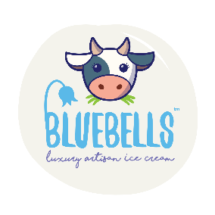
Bluebell Dairy School Booking Form
Please complete this form and email to education@bluebelldairy.co.uk

Date preferred:
Alternative dates:
School name and address:
Contact name:
Contact address:
Contact email:
Email for invoicing:
Contact number:
Topic: Choose your 1 topic activity | Field to fork:  - Cow to Cone  - Butter Making  - Fruit and Vegetable Tasting  - Pumpkin Lifecycle  Farm animals:  - Mini Farmer Days  - Animal Care and Welfare  - New Arrivals  Soil:  - Wriggly Worms  - Pumpkin Planting  - Seed Planting  Pollination:  - Seeds and Flowers  - Bees and Butterflies  Wildlife:  - Mini Beast Hunting  - Habitat Investigation  Rural Crafts:  - Countryside Crafts  Festive Fun:  - Farmyard Festivities  - Reindeer & Cheer
Total amount of children:
Total amount of adults ( Teachers/supervisors free on 1:5 ratio)
Number of children with special additional needs:
Number of children using wheelchair:
Arrival time (9.30am onwards) |  | Departure time: (last time 2.30pm)
What is your main learning objective?
Key stage/year group:
PO number for invoicing if required:
Any known allergens:

Please note an £80 deposit must be paid within 2 weeks of booking in order to secure the visit

The remaining balance must be paid 2 weeks after the day of your visit

Pricing for schools visits:

Child | £10 per child + VAT
Teacher/Supervisor | Free on 1:5 ratio
Additional adults | £5 per extra adult + VAT

