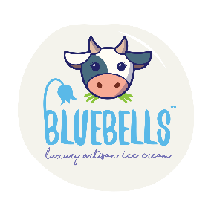
Bluebell Dairy School Booking Form 2026/27
Please complete this form and email to education@bluebelldairy.co.uk

Date preferred:
Alternative dates:
School name and address:
Contact name:
Contact email:
Email for invoicing:
Contact number:
Choose ONE topic:  Please refer to our brochure for more information. Please note some topics are not available for larger group sizes.  Some topics are not available for Funded Visits. | Available All Year:  - Cow to Cone  - Mini Farmer Days  - Animal Care and Welfare  - Countryside Crafts  Feb-May Only:  - New Arrivals  Spring-Summer Only:  - Seed Planting  June/July Only:  - Mini Beast Hunting  Sept-Oct Only:  - Pumpkin Lifecycle  December Only:  - Farmyard Festivities  - Reindeer & Cheer
Total amount of children:
Total amount of adults ( Teachers/supervisors free on 1:5 ratio)
Number of children with special additional needs:
Number of wheelchair users:
Arrival time (9.30am onwards) |  | Departure time: (last time 2.30pm)
What is your main learning objective?
Key stage/year group:
PO number for invoicing if required:
Any known allergens:
Our animal feed contains NUTS

Please note an £80 deposit must be paid within 2 weeks of booking in order to secure the visit

The remaining balance must be paid 2 weeks after the day of your visit

Pricing for school visits:

Child | £10 per child + VAT
Teacher/Supervisor | Free on 1:5 ratio
Additional adults | £5 per extra adult + VAT
For Funded Visits, we request an £80 deposit to secure your chosen date. This will be refunded to you after your visit, please complete your bank details below to help us with this.

Account Number: | Sort Code:
Name: | Name of Bank:

OFFICE USE ONLY:
DEPINV: ECORSK:

